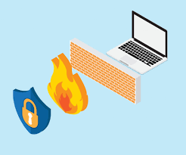

Factory Reset Lab Writeup

Sophia Zhang | Period 5 Cybersecurity | 2022-2023



**Purpose**

To perform a factory reset on a Palo Alto PA-220 firewall.

**Background:**

We performed a factory reset on the Palo Alto firewall for a variety of reasons. One is to remove any prior configurations that have been set on the firewall by others. It is crucial that we do not interfere with previous configurations, as it can easily get confusing and messy. Specifically, passwords can also be previously set on the firewall, and a factory reset can remove the passwords so we can get into the firewall.

Firewalls are security devices that that monitors traffic to and from our networks, and blocks traffic based off security rules. Firewalls allow us to have access to the internet, but also prevents others from the internet from accessing resources on our internal network. Firewalls are present in SOHO networks.

**Lab Summary:**

We entered maintenance mode on the Palo Alto PA-220 firewall and performed a factory reset on the firewall.

**Lab Procedure:**

1. Plug the firewall into a power source
2. Go to Putty as the firewall is booting

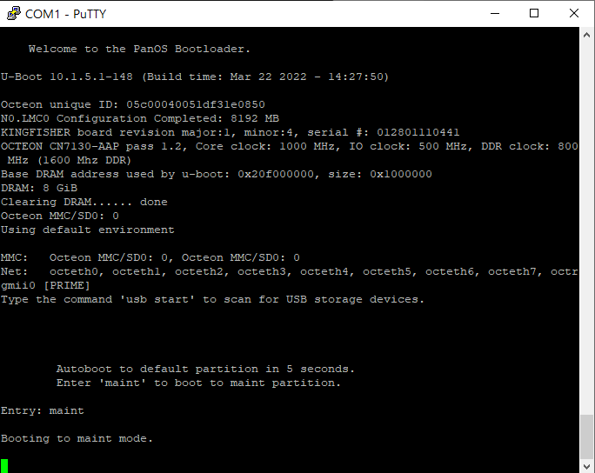

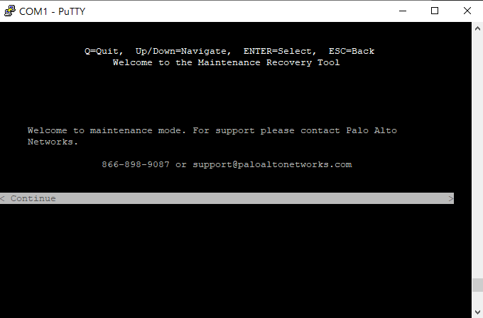

1. Type “maint” and press “enter” over and over again until maintenance mode is entered (refer to image below)

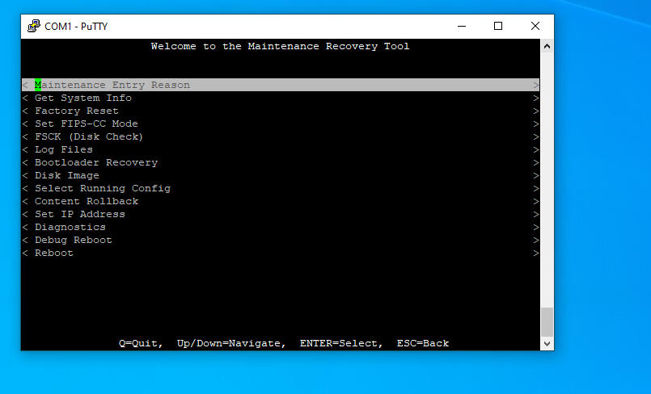

1. Go down to “factory reset” and press enter. The following screen should show.

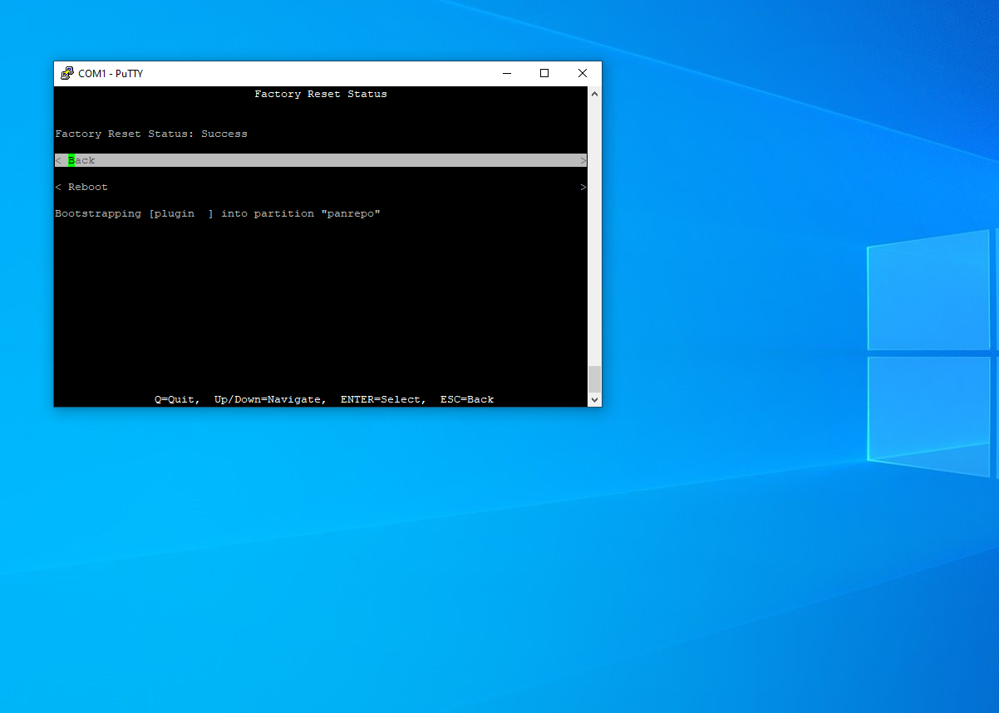

1. Select “reboot” to perform a factory reset on the firewall.

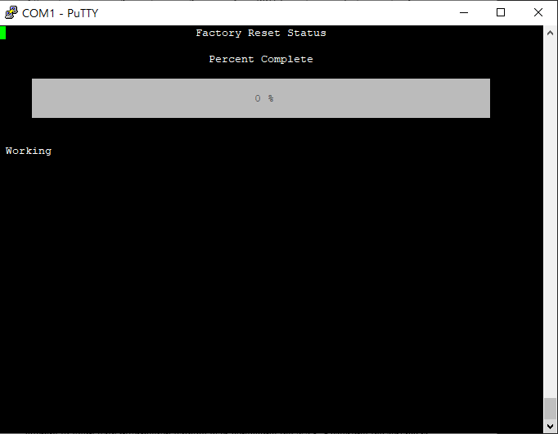

1. Wait until the following screen shows:

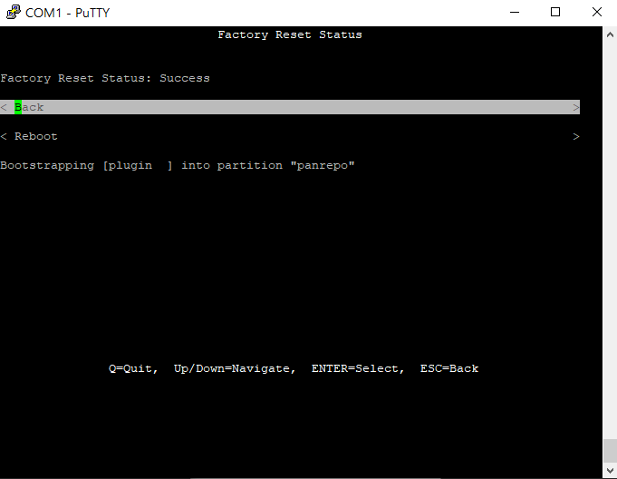

1. Reset the password on the firewall. Enter the old password as “admin”

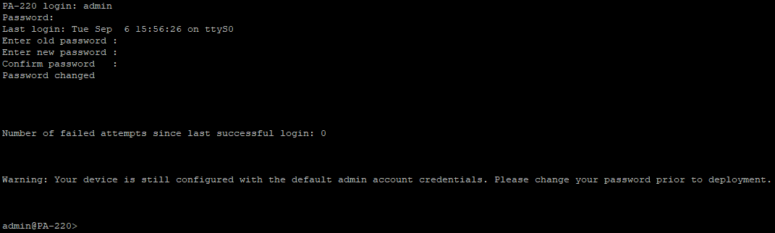

**Problems:**

One problem that we had was that our firewall was not plugged in initially, so we could not do anything. Secondly, we had to reset our firewall multiple times throughout the lab due to misunderstanding of the instructions.

**Conclusion:**

In this lab, we performed a factory reset on our Palo Alto PA-220 firewall by entering maintenance mode, resetting the firewall, and resetting the password.